Sound in Air

2017-02-08

Cory Wolfe

Lab Partners: Ryan Goulden and Marshall Loper

For this experiment sounds at varying frequencies were played into a tube of varying length in order to find the resonant lengths, as visible on a graph. The hypothesis of this experiment is that the longitudinal sound waves may be relatable to the standing waves the group had previously experimented with.

This experiment required a speaker, sound sensor, analog to digital converter, function generator, DataStudio and a resonance tube apparatus. The equipment was set up in a way to allow for sound refelecting from the tube to be sensed. A diagram of the apparatus is shown in Figure 1. Useful equations include:

$v=\sqrt{\frac{γRT}{M}}$

* γ (1.4) is the correction constant for air, R (8.314) is the gas constant, T is the temperature and M (28.7×10−3 kg mol) is the average molecular weight of air.

Figure 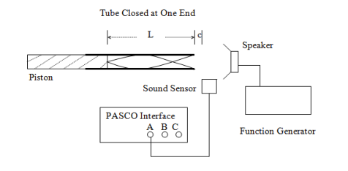1: Diagram of Lab Setup

The procedure for this experiment involved setting up the apparatus as shown in Figure 1. After the apparatus was set up the speaker was run at 1.5, 2.5 and 3.5 kHz. The piston was moved to find a resonant length, which was visualized as minima on the sound sensor's graph. After five resonant lengths were recorded the piston was removed and the tube's length was recorded. This data is available in Figure 2.

After this was completed the function generator was set to 200 Hz and then increased to find the first five resonant frequencies for an open tube of the measured length. This is available in Figure 3.

|  |  |  |  |  |  |
| --- | --- | --- | --- | --- | --- |
|  | L1(cm) | L2(cm) | L3(cm) | L4(cm) | L5(cm) |
| 1.5 kHz | .5 | 6.5 | 20 | 34.1 | 47 |
| 2.5 kHz | 11.5 | 18.4 | 26.5 | 33.5 | 39.7 |
| 3.5 kHz | 1.2 | 7.5 | 10.8 | 15.6 | 20.6 |
| Length (tube) | 58.5 |  |  |  |  |

|  |  |  |  |  |  |
| --- | --- | --- | --- | --- | --- |
|  | f1(Hz) | f2(Hz) | f3(Hz) | f4(Hz) | f5(Hz) |
| 58.5 cm tube | 300 | 575 | 840 | 1250 | 2250 |
| Ave. Δf | 390 Hz |  | λ | .8795 m |  |
|  | 1.5 kHz | 2.5 kHz | 3.5 kHz |  |  |
| Ave. diff (cm) | 9.3 | 5.64 | 3.88 |  | Vsound(m/s) |
| Velocity | 279 | 282 | 271.6 |  | 343 |
| Error | 18.6% | 17.8% | 20.8% |  |  |

Figure 2: Table of Piston Data

Figure 3: Table of Data and Calculations

In this lab the group found and calculated the velocity of sound given the information we tabulated. The error was around nineteen percent, which is higher than would be wanted, but since the error was very precise, there is a chance that the function generators do not output exactly the frequency indicated by the knob. For the second experiment (differing frequencies) the wavelength was calculated given the average difference to be .8795 meters. This is interestingly approximately 1.5 times the length of the tube.